1. I have implemented the DNN using SGD. This algorithm works for any number of hidden layers (Even with zero!). Just edit the hyper parameters as you wish from the **main** function. If you want to tune the hyper parameters, add each parameter to the corresponding list in the **main** function, and change the key word argument of **dnn** class to **True**. If the tune parameter is set to false, the network chooses a random hyperparameter set.
2. At 3 Hidden layers and 64 hidden units per each hidden layer, check_grad function returns the following output:

**Check grad: 8.48675979004169e-07**

**Hyper Parameters used are:**

Batch Size = 254,

Epsilon = 0.09,

Epochs = 300,

Alpha = 0.0025,

Hidden layers= 7,

Hidden units at each hidden layer = [512, 512, 512, 512, 512, 512, 512]

The following is the loss for last 20 epochs, and final test loss and accuracy

Epoch 280 , and loss 0.040836453339212084

Epoch 281 , and loss 0.04080345183386274

Epoch 282 , and loss 0.04077048268356996

Epoch 283 , and loss 0.04073753906553885

Epoch 284 , and loss 0.04070462817376836

Epoch 285 , and loss 0.040671748133887256

Epoch 286 , and loss 0.04063889139504536

Epoch 287 , and loss 0.04060606970019438

Epoch 288 , and loss 0.04057327370535337

Epoch 289 , and loss 0.040540507913879496

Epoch 290 , and loss 0.04050777167114746

Epoch 291 , and loss 0.040475065230115015

Epoch 292 , and loss 0.040442393311240075

Epoch 293 , and loss 0.0404097444967561

Epoch 294 , and loss 0.04037712921089954

Epoch 295 , and loss 0.04034454127191848

Epoch 296 , and loss 0.040311985156857875

Epoch 297 , and loss 0.04027945925601887

Epoch 298 , and loss 0.04024696299719237

Epoch 299 , and loss 0.040214497047978345

Epoch 300 , and loss 0.04018205912911439

**Training Error is 0.04018205912911439**

**Test Error is 0.8894396867771397**

**Test accuracy 90.02**

**Screenshot:**

**Weight Plots for each layer at these hyper parameters:**

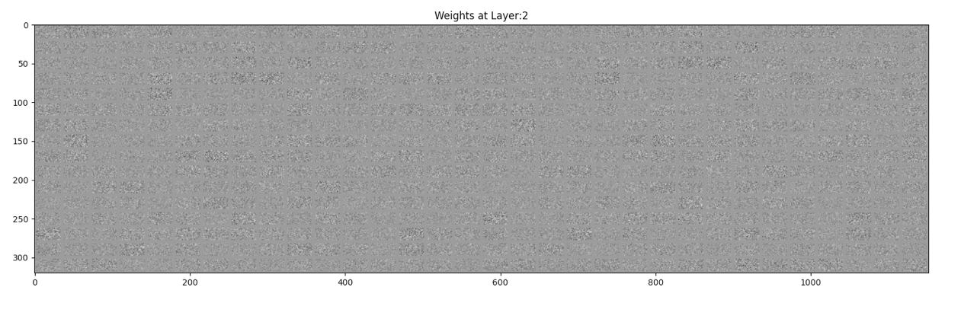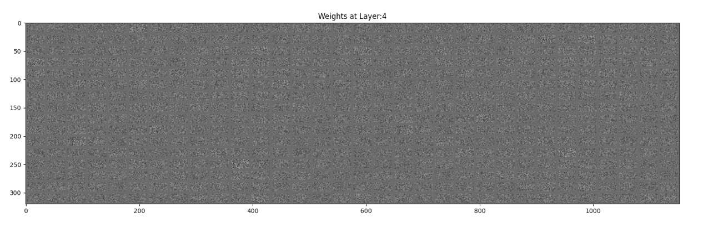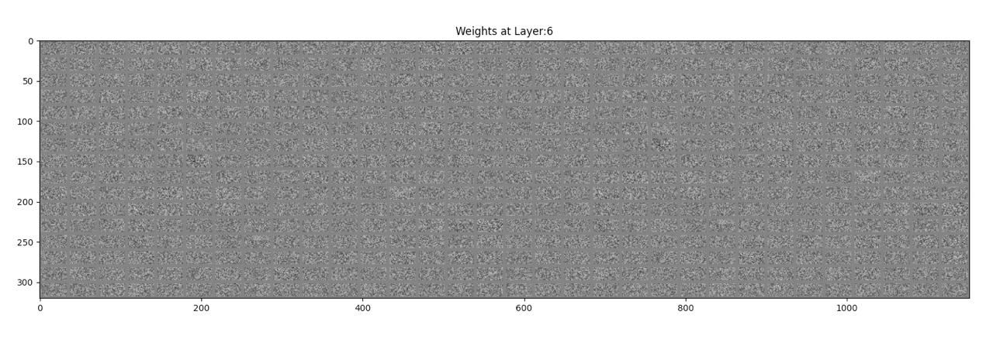

**Hyper Parameters used are:**

Batch Size = 254,

Epsilon = 0.09,

Epochs = 200,

Alpha = 0.0025,

Hidden layers= 6,

Hidden units at each hidden layer = [254, 254, 254, 254, 254, 254]

The following is the loss for last 20 epochs, and final test loss and accuracy

Epoch 181 , and loss 0.03079890284608955

Epoch 182 , and loss 0.030778589952512498

Epoch 183 , and loss 0.03075770897291907

Epoch 184 , and loss 0.03073550271534558

Epoch 185 , and loss 0.03071373218922566

Epoch 186 , and loss 0.03069290763156216

Epoch 187 , and loss 0.03067186744579173

Epoch 188 , and loss 0.030650605454243765

Epoch 189 , and loss 0.030629358867598048

Epoch 190 , and loss 0.030608186227203838

Epoch 191 , and loss 0.030586724371946556

Epoch 192 , and loss 0.03056553952436401

Epoch 193 , and loss 0.030543902117510735

Epoch 194 , and loss 0.030522602382308132

Epoch 195 , and loss 0.030501143977252572

Epoch 196 , and loss 0.030479403414290156

Epoch 197 , and loss 0.03045764993283975

Epoch 198 , and loss 0.030435960465143828

Epoch 199 , and loss 0.030414091530481933

Epoch 200 , and loss 0.030392264417619132

**Training Error is 0.030392264417619132**

**Test Error is 1.0013279776909778**

**Test accuracy 89.28999999999999**

Weight Plots for each layer at these hyper parameters:

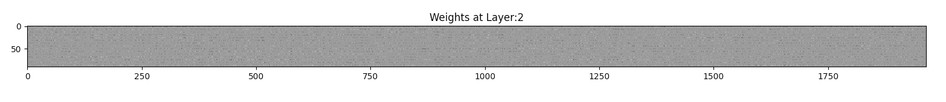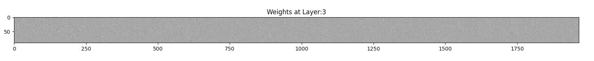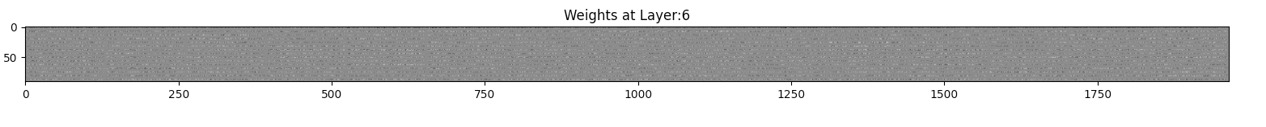

**Hyper Parameters used are:**

Batch Size = 254,

Epsilon = 0.09,

Epochs = 1,

Alpha = 0.0025,

Hidden layers= 0,

Hidden units at each hidden layer = []

The following is the loss for last epoch, and final test loss and accuracy

Epoch 1 , and loss 0.5853625684133672

**Training Error is 0.5853625684133672**

**Test Error is 0.6099911842736919**

**Test accuracy 78.96999999999997**

Weight Plots for each layer at these hyper parameters:

